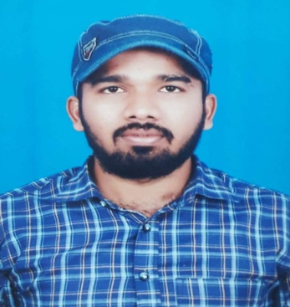
CURRICULUM VITAE
S . SREEKANTH
H. No. 8-164,
Velgode Village & Mandal, |  | Cell : 8700177721
Kurnool Dist. A.P. - 518 533. |  | Email : sakunalasreekanth@gmail.com
CAREER OBJECTIVE

To work in an environment that gives me an opportunity for learning new things and Facing stimulating challenges. To put my skills to best use of the organization that is taking care of my career.

EDUCATIONAL QUALIFICATIONS

- I have Completed my B.Ed in English from Rayalaseema University in 2023 with 75%.
- I have recently qualified in AP TET Exam in 2024 with 116 marks.
- I have Completed my Post Graduation in M.A English from Ambedkar University in Hyderbad in 2020 with 65%.
- B. Tech. (EEE) from Shanthiram Engineering College, Nandyal in 2016 with60.92%.
- Intermediate (M.P.C.) from Sri Chaitanya Junior College, Uppal, Hyderabad in 2012 with 91%.

- S.S.C. from ZPHS High School, Velgode Village in 2010 with 89%.

EXPERIENCE

- I have 7 years of experience in teaching English in different Coaching centers and Colleges like IRISE Academy, EVEREST Coaching center in Hyderabad, Meghana Coaching Center, Govt Polytechnic College, Sri Ramakrishna Degree College and SVR Engineering College in Nandyal. I gave training for different competitive exams for the students those who are preparing for SSC (CGL, CHSL, STENO and MTS), Bank P.O’s, and Clerks, S.I, P.C, DSC, ICET, IELTS, CAT, C-SAT for Degree and B. Tech Students.
- I took training for competitive English in New Delhi for 1 year.
- I worked as a guest lecturer in ESC GOVT POLYTECHNIC College in Nandyal.
- I have been working as an English Lecturer in SRI RAMA KRISHNA DEGREE COLLEGE (Autonomous) for the past Four years in Nandyal.
TECHNICAL SKILLS

- Type Writing English in Higher Grade - 45 wpm.
- Short Hand in Lower Grade - 80 wpm.
COMPUTER SKILLS

- MS - Office

PERSONAL SKILLS

- Good communication
- Hard working
- Positive Attitude

HOBBIES

➢ | Listening Music
➢ | Reading Books
PERSONAL DETAILS :
Name |  | : | S . SREEKANTH
Father’s Name |  | : | S. Nagendrudu
Date of Birth |  | : | 19-07-1995
Gender |  | : | Male
Nationality |  | : | Indian
Religion |  | : | Hindu
Marital Status |  | : | Un-Married
Languages Known |  | : | Telugu, Hindi & English

DECLARATION

I hereby declare the above information is accurate and I assured that I will provide best of my service to organization.

Date:

Place: ( S . SREEKANTH)

